Comparison of Traditional OBD-II Diagnostic Software and AI-Based Systems for Predictive Vehicle Maintenance
Rujanac Mirza
Faculty of Information Technologies, University “Džemal Bijedić”, Mostar, Bosnia and Herzegovina
mirza.rujanac@edu.fit.ba
Abstract – This paper examines the differences between traditional OBD-II diagnostic software and AI-based systems used for predictive vehicle maintenance. The first approach is built around reading diagnostic trouble codes, monitoring live data, and supporting fault detection after the vehicle has already recognized an abnormal condition. The second approach relies on data analysis, machine learning, and condition monitoring in order to estimate potential failures before they become critical. The paper explains the fundamentals of both approaches, highlights their practical advantages and limitations, and compares them from the perspective of accuracy, speed, cost, technical complexity, and real-world usability. The goal is to show that OBD-II and AI-based diagnostics should not be viewed as direct opposites, but as two complementary approaches that serve different purposes in modern vehicle maintenance.

Keywords – OBD-II, vehicle diagnostics, diagnostic trouble codes, artificial intelligence, predictive maintenance, automotive software
- Introduction
In the automotive industry, vehicle diagnostics play an important role in identifying problems, improving safety, reliability, and overall performance. As vehicles have more features, such as sensors for recognizing signs, automatic breaking, gear shifting etc. Each manufacturer uses its own implementation of electronic control units (ECUs), therefore the need for accurate and efficient diagnostic methods has become more important.
In today’s world the most common and most used approach to vehicle diagnostics is based on the OBD-II (On-Board Diagnostics) standard, which can read diagnostic trouble codes (DTCs) sent from the ECU. However, there is one main disadvantage when it comes to these OBD-II readers is that their effectiveness depends on the person’s ability to correctly read and recognize the DTC, which can lead to incorrect diagnosis or unnecessary repairs if misunderstood.
Recent growth in artificial intelligence has allowed us to introduce new possibilities in the automotive industry, such as preventing mistakes or improving overall health of our automobile. AI-based systems are trained on large datasets collected from vehicles, and can later analyze data in real time.. Afterwards, the AI diagnostic system can save a lot of person’s time by providing possible causes or patterns associated with a DTC, therefore making the fix quicker and cheaper, improving efficiency and safety. At the same time the AI diagnostic system can predict potential failures before a DTC is triggered, shifting the approach from reactive troubleshooting to proactive maintenance.
This paper compares traditional OBD-II diagnostic software with AI-based diagnostic prediction and maintenance systems, focusing on their strengths, limitations, and practical applications in modern vehicles.
- FUNDAMENTALS OF OBD-II DIAGNOSTICS
Vehicle diagnostics has changed considerably over time. What began as a standardized way to detect faults related mainly to emissions has gradually developed into a broader process of monitoring vehicle condition and supporting maintenance decisions. In practice, two approaches are especially important today. The first is the traditional OBD-II diagnostic model, which identifies faults after they have already been recognized by the vehicle’s control system. The second is the AI-based predictive model, which analyzes current and historical data in order to estimate the likelihood of future failures before they become critical. Traditional OBD-II systems are still the most widely used solution in workshops and routine diagnostics, while AI-based systems are becoming more relevant because they introduce a more preventive and data-driven maintenance strategy.
- Traditional OBD-II Diagnostics
OBD-II, short for On-Board Diagnostics II, is a standardized diagnostic system used in modern vehicles to monitor the operation of important vehicle subsystems and report malfunctions. Although its regulatory purpose is strongly connected to emissions monitoring, OBD-II is also widely used in practice to retrieve fault information from systems related to the engine, transmission, and other electronically controlled functions. Its importance lies in the fact that it gives technicians and diagnostic software direct access to fault-related vehicle data through a common interface.
The system operates through the vehicle’s electronic control units, which continuously monitor input from sensors and actuators. When the ECU detects a value or operating condition outside the acceptable range, it stores a diagnostic trouble code, commonly known as a DTC. This code can then be retrieved by connecting a scan tool or diagnostic software to the OBD-II port. In many cases, the process is accompanied by activation of the malfunction indicator lamp, better known as the “Check Engine” light, which informs the driver that the vehicle has detected a fault requiring attention.
One of the main strengths of OBD-II is standardization. Because vehicles follow defined communication rules and connector standards, many diagnostic tools can work across different manufacturers and models, even though some advanced functions may remain manufacturer-specific. This standardization is one of the reasons OBD-II became so widely used in both professional and consumer diagnostics. In a practical sense, OBD-II software usually serves as the first step in fault detection because it allows users to read stored codes, inspect live sensor data, and observe the condition of the monitored system.
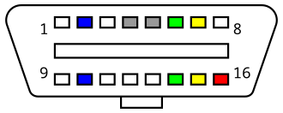
Fig 1. Standard OBD-II connector pinout used for communication between the vehicle and the diagnostic tool.
- OBD-II Diagnostic Software in Practice
Traditional OBD-II diagnostic software is designed mainly to interpret information that has already been generated by the vehicle. In most cases, the software reads stored DTCs, displays freeze-frame data, shows real-time sensor values, and allows fault codes to be cleared after the problem has been addressed. This makes OBD-II tools very useful for confirming that a problem exists and identifying the subsystem in which abnormal behavior was detected.
However, the software itself does not usually determine the full root cause of the fault. It presents the code and associated data, but the final interpretation still depends on the experience and technical understanding of the user. A single DTC may point toward one subsystem while the actual cause may lie elsewhere, such as in wiring, sensor contamination, mechanical wear, or interaction with another component. For that reason, traditional OBD-II software is highly useful, but it is still largely reactive and dependent on human interpretation.
Another important limitation is timing. OBD-II systems are generally designed to detect and report problems after they have reached a defined threshold. In other words, they are very effective at identifying faults that the system has already recognized, but they are far less capable of estimating that a fault is likely to occur in the near future. This reactive nature is one of the main reasons why traditional diagnostics alone may not be sufficient for modern maintenance strategies focused on reliability, reduced downtime, and cost optimization.
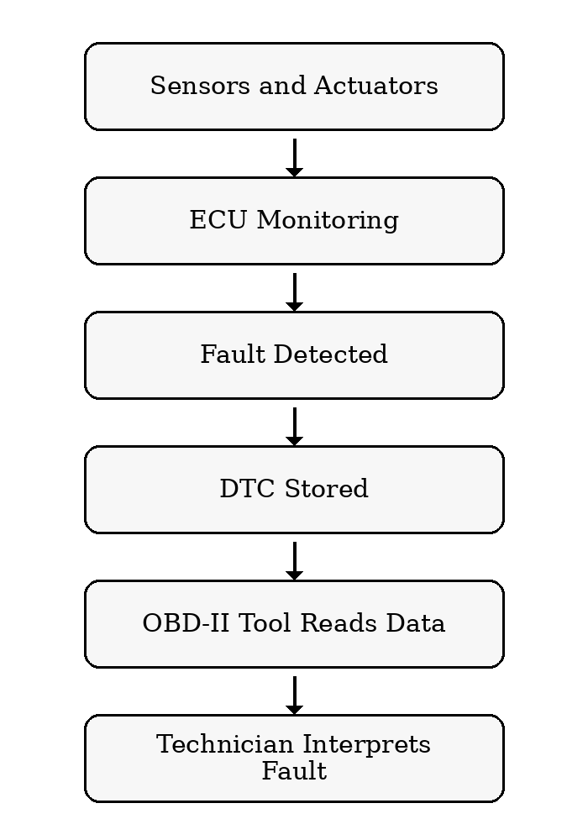
Fig 2. Standard OBD-II connector pinout used for communication between the vehicle and the diagnostic tool.
- AI-Based Predictive Maintenance System
AI-based predictive maintenance follows a different principle. Instead of waiting for a fault code to appear, these systems use large sets of historical and real-time vehicle data to detect patterns associated with abnormal behavior, performance degradation, or likely future failure. In research literature, predictive maintenance is generally described as a strategy based on condition monitoring and data analysis, where maintenance decisions are made according to the estimated health state of the system rather than only after a breakdown or a fixed service interval.
In the automotive field, these systems may analyze sensor readings, fault history, driving conditions, operating load, and usage patterns collected over time. Artificial intelligence, especially machine learning, makes it possible to recognize relationships in this data that are difficult to capture through fixed rules alone. As a result, AI-based diagnostics can support earlier fault recognition, estimate probable component degradation, and suggest that maintenance should be performed before a more serious failure occurs.
The advantage of this approach lies in better planning and more efficient intervention. Instead of reacting only when the vehicle stores a fault code, AI-based systems can warn that a certain component is showing signs of deterioration and may require service soon. This can reduce downtime, prevent secondary damage, and lower maintenance costs. At the same time, these systems also have limitations. Their performance depends heavily on data quality, the relevance of the selected model, and the correctness of training and validation procedures. Poor or incomplete input data can quickly reduce reliability.
- KITTI Dataset
The KITTI dataset, developed by Karlsruhe Institute of Technology and Toyota Technological Institute at Chicago, is created specifically for training and benchmarking autonomous driving systems. It is designed to work with 2D images, 3D laser scans and GPS measurements. For that purpose, they used four high resolution cameras, a LiDAR scanner and a GPS device.
The dataset content is diverse and categorized. Developers used a modified Volkswagen Passat to record the data (Fig. 4). They drove the car throughout several different settings (city, highway, rural, etc.). All the relevant data (cars, pedestrians, cyclists, etc.) is labelled. After recording the data, the system synchronizes it in space and time (Fig. 5), so the data from one sensor lines up directly with the data from other sensors. This step is crucial to generate a 3D map which is later used to train or benchmark various systems.
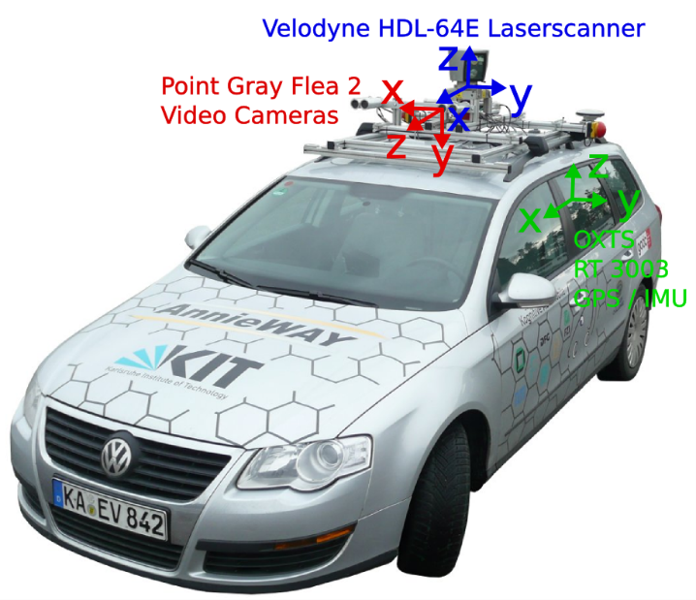
Fig. 4 VW Passat with equipment used to record the dataset. [4]
All the data is available online in various formats so anyone can use it for training, benchmarking, testing and manipulation [3]. Except autonomous driving, which is its main purpose, this dataset can also be used for studying and researching multi-sensor integration, robotics, computer vision, etc.
In the dataset, 2D data is primarily used to label objects detected in 3D space as well as for easier navigation in the map generated by the GPS device. YOLO is one of the most used 2D detection algorithms in KITTI benchmarks. The other commonly used algorithm is the Faster R-CNN which we will compare to YOLO.
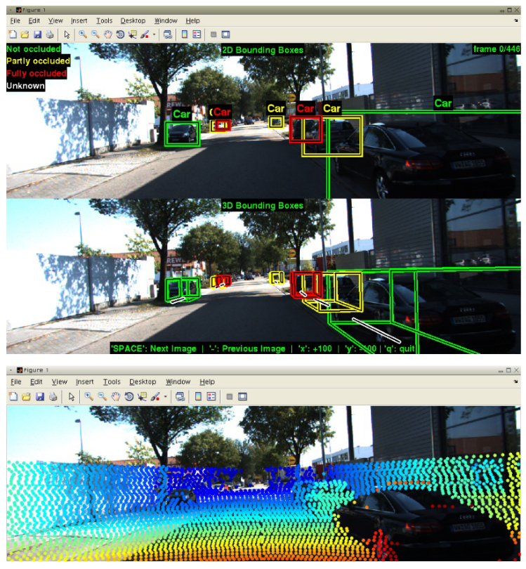
Fig. 5 Screenshot of a development kit used for the KITTI dataset. We can see both 2D and 3D data visualization. [4]
- Analysis: YOLO vs Faster R-CNN
To observe YOLO’s benefits and drawbacks in real-world usage, we will compare its benchmark results in KITTI to the results generated by the Faster R-CNN [9]. Faster R-CNN is an evolution of Fast R-CNN [8] object detection algorithm which is also an evolution of R-CNN [7], originally presented in 2014. The reason we won’t compare YOLO to previous evolutions of Faster R-CNN is because this final evolution is considered as the fastest and the most efficient one, while not cutting down on accuracy.
- Faster R-CNN: Brief Analysis and Test Results
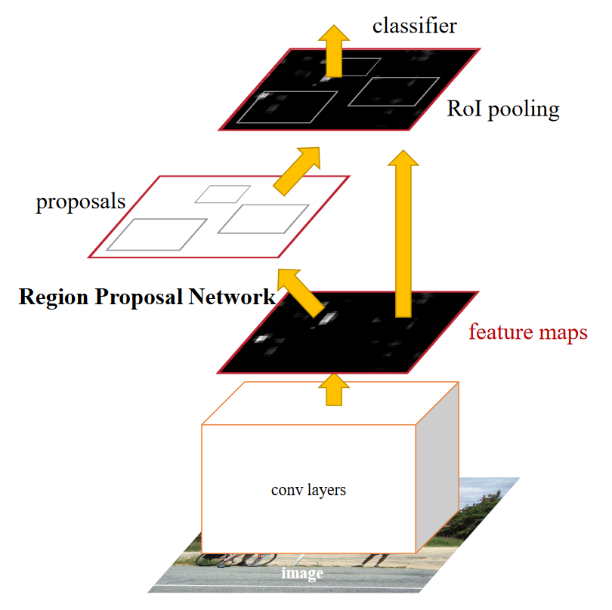
Fig. 6 Faster R-CNN network simplified. [9]
Unlike YOLO, Faster R-CNN introduces several steps to detect objects. To fully analyse an image, Faster R-CNN utilizes two crucial steps (Fig. 6). The first one is the Region Proposal Network (RPN), which generates the region of interest (RoI) for each potential object. After that, proposed regions are sent separately to the connected layers of the network. Those layers then analyse the regions and set classifications for them, outputting a label and a refined bounding box for each RoI. As we can see this process is more complex than YOLO, requiring more computing power and time. Due to these circumstances, we can assume that Faster R-CNN is more accurate than YOLO. By observing the following comparison, we will see if that’s true or not.
If we observe the analysis by Fan, Brown and Smith [12], we can see that Faster R-CNN is highly dependent on training and scaling. When they initiated the training process on the KITTI dataset, mid-training results weren’t that impressive (Fig. 7). It’s important to note that they didn’t start training the model from scratch, instead they used an ImageNet [13] pretrained model.
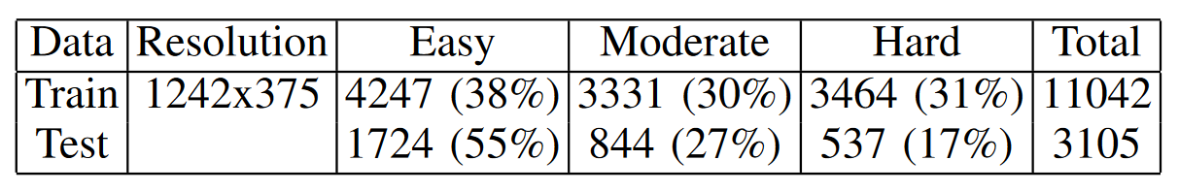
Fig. 7 Mid-training results for Faster R-CNN. The KITTI dataset provides three different difficulty categories in its collection of images. [12]
After completing the training process, the results improved significantly (Fig. 9). Also repeating the training process shows substantial improvements, meaning that if used for specific purpose, this model is very training dependent. Furthermore, scaling also played a significant role in this. If the model is trained with higher resolution images, accuracy will be improved (Fig. 8). This also comes at a cost in terms of efficiency, since iterative training, especially with high resolution images, requires a lot more time (Fig. 10).
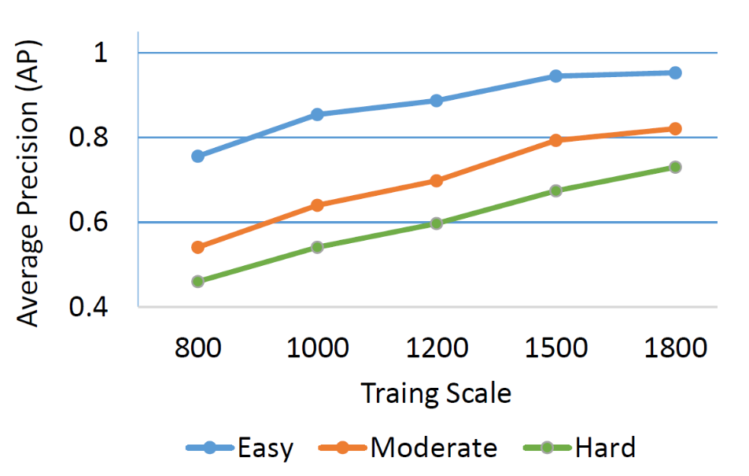
Fig. 8 Observation of the Faster R-CNN models average precision after training with different scaling settings. [12]
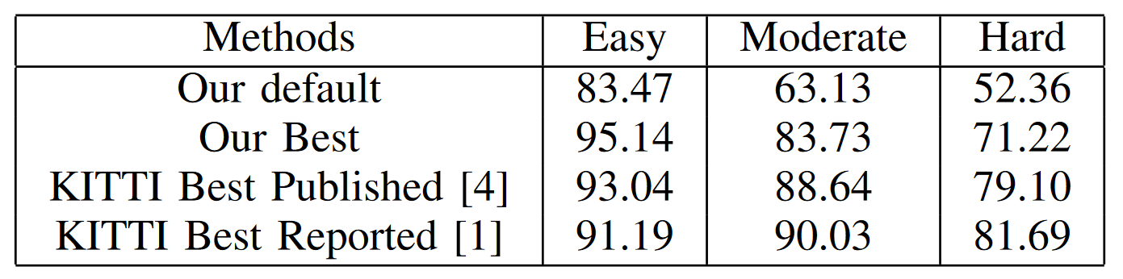
Fig. 9 Significant performance improvement after training (first row) and iterative training (second row), compared to the best results on the KITTI website. [12]
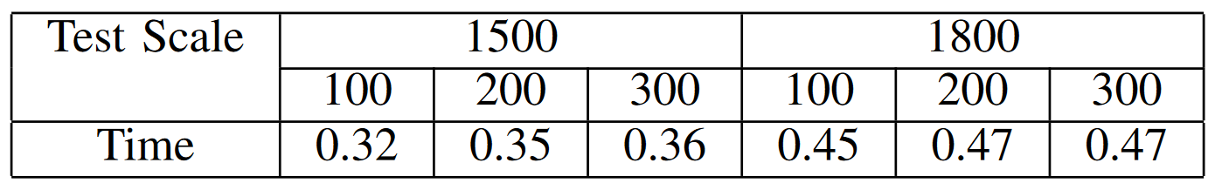
Fig. 10 Faster R-CNN execution time in seconds. The times are shown for two different scales (1500 and 1800 pixels), with different number of proposals by the RPN. Difference in the number of proposals makes an unnoticeable performance hit, while the larger scale slows the process significantly. [12]
- YOLO Performance in KITTI
Since we decided to use the Faster R-CNN for this comparison, the final version of R-CNN, we will do the same for the YOLO. To analyse YOLO algorithms performance in KITTI dataset we will take a look at the research performed by G. Al-refai and M. Al-refai [10]. They used YOLOv3 [5], the final version of YOLO, created by Redmon, its original developer and Ali. The pre-trained model they used is based on COCO dataset [14], unlike Faster R-CNN which was pre-trained on ImageNet, but that shouldn’t make a difference since both are general purpose datasets, meaning they consist of large variety of data, without any bias. Since YOLO algorithm, as previously mentioned, struggles with detecting smaller objects, its accuracy will be presented in two values, Precision (1) and Recall (2).
Precision = Truepositives / (Truepositives + Falsepositives) (1)
Recall = Truepositives / (Truepositives + Falsenegatives) (2)
This way we will know how accurate the algorithm is with detected objects (are there any false positives) and its overall accuracy (are there any undetected objects that should’ve been detected). The researchers used 300 random images from the datasets, meaning there are no different difficulty categories.
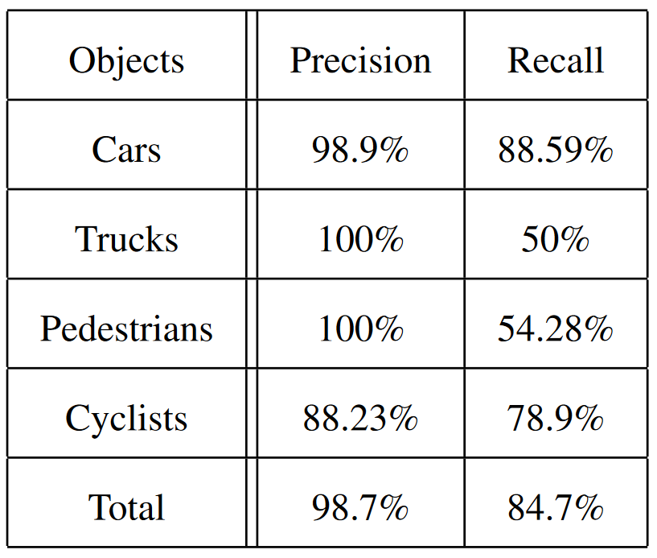
Fig. 11 Precision (1) and Recall (2) results based on 300 random images test. [10]
We can observe a very high precision, while recall values vary a bit (Fig. 11). It is important to note that there were only six trucks within 300 test images, so the results for trucks can’t be taken into consideration. Despite this very high precision for pedestrians, there was also a lot of undetected ones. The same can be said for cyclists, but the recall for them isn’t as low.
We can see that the algorithm is pretty accurate with detected objects, while it missed quite a few pedestrians and cyclists, showing its struggles with smaller objects. Since this research wasn’t extensive and detailed as Fan, Brown and Smith did with Faster R-CNN, we will have to observe one more research.
- Quantitative Evaluation and a Community-Driven Project
To fully challenge the YOLOv3 algorithm and to have a fair comparison to the Faster R-CNN, Yang and Yuchi [11] benchmarked these two algorithms with a large set of test data from KITTI, categorized into three different difficulties (easy, moderate and hard). This test also includes a community-driven evolution of YOLO, named YOLOv5 [6]. This version of YOLO was created by the community, and it improves directly upon YOLOv3. It shows significant improvements in accuracy while carrying on its speed (Fig. 12).
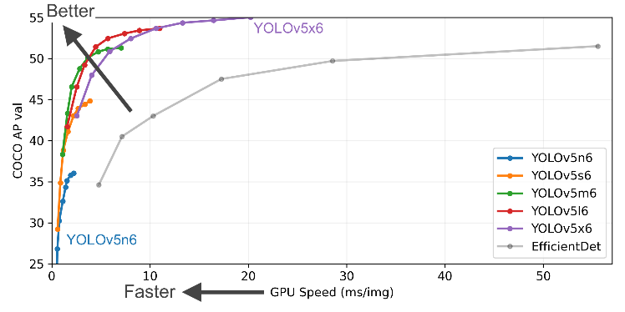
Fig. 12 YOLOv5’s performance in COCO dataset benchmark. [15]
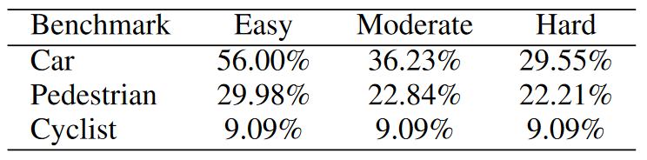
Fig. 13 KITTI benchmark results using a modified YOLOv3. [11]
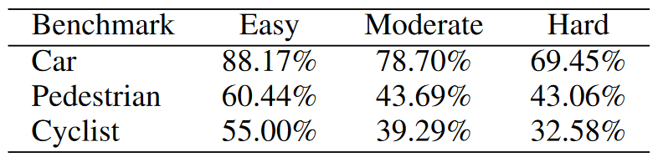
Fig. 14 KITTI benchmark results using a modified YOLOv5. [11]
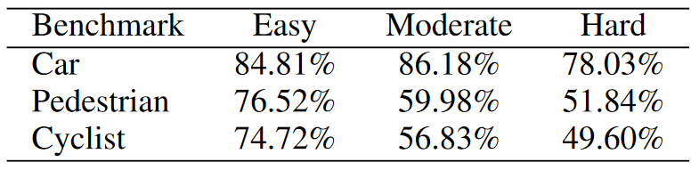
Fig. 15 KITTI benchmark results using a modified Faster R-CNN. [11]
If we look at the results provided in tables (Fig. 13, 14, 15), we can see that Faster R-CNN outperforms both YOLO revisions. Not only it has better accuracy almost in every scenario, but it also has a smaller drop-off when faced with more demanding data.
As for the YOLO, the v3 showed worse results than previously due to a much larger and demanding dataset. The v5 had much better results, even comparable to Faster R-CNN in some cases, which is really impressive if we take running time into account (Fig. 16).
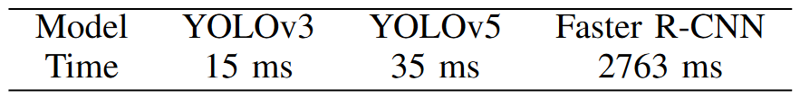
Fig. 16 Running time per frame for all three models. Faster R-CNNs speed isn’t even comparable to both YOLO v3 and v5, while YOLOv5’s slight lag behind v3 is more than worth it considering the improvements in accuracy. [11]
- Conclusion
Concluding this research, there are quite a few takeaways from it. Firstly, we can see how challenging it can be when facing an object detection algorithm with a use case specific dataset like KITTI. If the model isn’t adapted, i.e. retrained for that purpose, it won’t perform well. While pre-trained models can be useful for general purpose, they are still highly dependent on further modifications for any specific use case.
After analysing YOLO algorithm and its successors, YOLOv3 and YOLOv5, we learned how approaching something from a different angle can play a big role. Without YOLO, there wouldn’t be high-performing object detection algorithms which are usable in real-time, at least as we know of them. Every other algorithm used complex networks, which required a lot of computing power and time to predict objects, which isn’t a problem if speed isn’t a priority. But if we want to have advanced autonomous driving systems, that are safe, reliable, relatively easy to implement and able to make real-time decisions, then a fast and efficient 2D object detection algorithm is a must.
YOLO enabled us to use basic cameras for object detection, even at movie-like framerates. Especially after its third and community-driven fifth revision, it became very accurate and improved in small object detection accuracy. Even though we had algorithms like Faster R-CNN with remarkable accuracy, they weren’t that useful for any real-time application, where instant reaction is a requirement. Of course, when accuracy is a priority and we have a little bit more time at our disposal, then Faster R-CNN and other more accurate algorithms are still definitely a solution, since YOLO still lags behind them in accuracy.
With that said, we can conclude that object detection technologies are just like any other technology when it comes to developing them and improving them. As we keep pushing boundaries with what’s possible to achieve with artificial intelligence, we are still limited with computing power. That sometimes leads us to make compromises and decide between benefits and trade-offs. In our case, for real-time detection in autonomous driving, YOLO is a way to go. The time will tell us if YOLO will be able to catch up with the accuracy of slower algorithms or if we will be able to make faster processing units so algorithms like Faster R-CNN can be ran as fast as YOLO.
References
- J. Redmon, S. Divvala, R. Girshick, A. Farhadi, You Only Look Once: Unified, Real-Time Object Detection, University of Washington, Allen Institute for AI, Facebook AI Research, arXiv:1506.02640v5, May 2016. Available: https://arxiv.org/abs/1506.02640.
- ResearchGate, The way YOLO presents object detection data, https://www.researchgate.net/figure/The-way-YOLO-presents-object-detection-data-22_fig5_340983355. Accessed: July 2024.
- The KITTI Vision Benchmark Suite, https://www.cvlibs.net/datasets/kitti/index.php. Accessed: July 2024.
- A. Geiger, P. Lenz, C. Stiller and R. Urtasun, Vision meets Robotics: The KITTI Dataset, The International Journal of Robotics Research 32(11):1231-1237, Sept. 2013. Available: https://www.researchgate.net/publication/258140919_Vision_meets_robotics_the_KITTI_dataset.
- J. Redmon, A. Farhadi, YOLOv3: An Incremental Improvement, University of Washington, arXiv:1804.02767v1, Apr 2018. Available: https://arxiv.org/abs/1804.02767.
- Ultralytics, YOLOv5: A state-of-the-art real-time object detection system, 2021. Available: https://docs.ultralytics.com. Accessed: July 2024.
- R. Girshick, J. Donahue, T. Darrell and J. Malik, Rich feature hierarchies for accurate object detection and semantic segmentation, UC Berkeley, arXiv:1311.2524v5, Oct. 2014. Available: https://arxiv.org/abs/1311.2524.
- R. Girshick, Fast R-CNN, Microsoft Research, arXiv:1504.08083v2, Sept. 2015. Available: https://arxiv.org/abs/1504.08083.
- S. Ren, K. He, R. Girshick and J. Sun, Faster R-CNN: Towards Real-Time Object Detection with Region Proposal Networks, Microsoft Research, arXiv:1506.01497v3, Jan. 2016. Available: https://arxiv.org/abs/1506.01497.
- G. Al-refai and M. Al-refai, Road Object Detection using Yolov3 and Kitti Dataset, International Journal of Advanced Computer Science and Applications (IJACSA), 11(8), 2020. Available: http://dx.doi.org/10.14569/IJACSA.2020.0110807.
- C. Yang and L. Yuchi, Object Detection in the KITTI Dataset using YOLO and Faster R-CNN, National University of Singapore, Nov. 2023. Available: https://www.researchgate.net/publication/375597758.
- Q. Fan, L. Brown and J. Smith, A closer look at Faster R-CNN for vehicle detection, IEEE Intelligent Vehicles Symposium (IV), Gothenburg, Sweden, 2016, pp. 124-129, doi: 10.1109/IVS.2016.7535375. Available: https://ieeexplore.ieee.org/document/7535375.
- O. Russakovsky, J. Deng, H. Su, J. Krause, S. Satheesh, S. Ma, Z. Huang, A. Karpathy, A. Khosla, M. Bernstein, A. C. Berg, L. Fei-Fei, ImageNet Large Scale Visual Recognition Challenge, arXiv:1409.0575v3, Jan. 2015. Available: https://arxiv.org/abs/1409.0575.
- T. Lin, M. Maire, S. Belongie, L. Bourdev, R. Girshick, J. Hays, P. Perona, D. Ramanan, C. L. Zitnick, P. Dollár, Microsoft COCO: Common Objects in Context, arXiv:1405.0312v3, Feb. 2015. Available: https://arxiv.org/abs/1405.0312.
- Ultralytics, YOLOv5 README.md. Available: https://github.com/ultralytics/yolov5. Accessed: July 2024.

